**Advance Database Project [COMP214(Sec.003)]**

**Project Name: Game Xplosion**

**Game Xplosion is a vibrant and interesting online gaming portal created to offer players of all ages and tastes an easy way to find, play, and interact. Game Xplosion strives to be the go-to location for both casual and ardent gamers with its extensive selection of games in a variety of genres.**

Team Members:

* Sanghak Oeng (301239607)
* KWOK Ting Hei (301246247)
* Leonardo Nunes (301263098)
* Gursimran (301273109)

ER-Diagram:

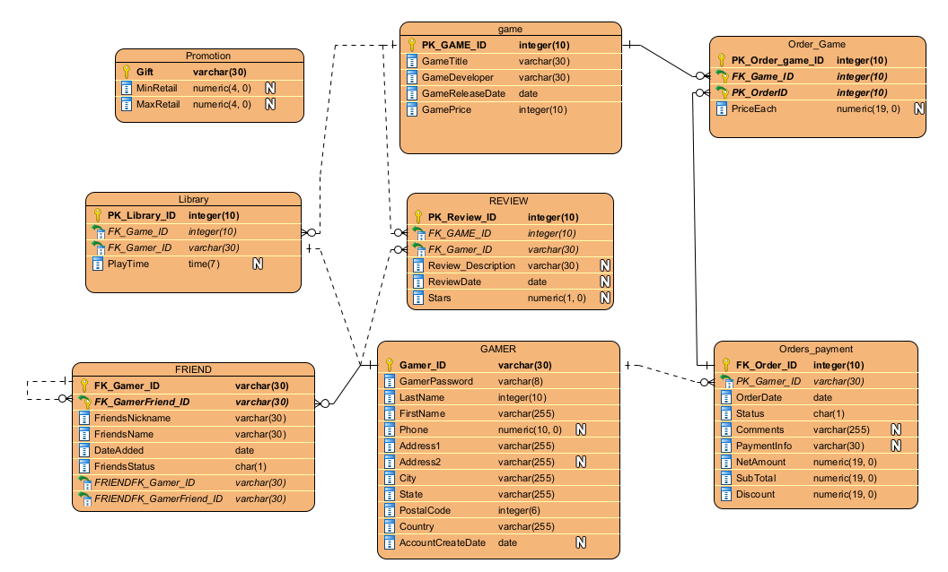

Mock-Up Screen:

